THE BUBBLE FIELD
CLOSURE ATTACK
G, the source sector, the weak scale, and the charged-lepton spectrum
Joseph Shields
Computation and formal reconstruction with ChatGPT
Status discipline
EXACT | CONDITIONAL | CANDIDATE | NO-GO | OPEN
The purpose of this paper is not to restate the programme. It closes the equations that can be closed, registers the bridges that remain conditional, and refuses to count numerical proximity as proof.

Executive result
This pass moves the Bubble Field from a visual ontology to an executable restricted gravitational model. The exact macroscopic source equations are now written, an interior relativistic star is reconstructed into the bubble variables, and a discrete candidate for the missing gravitational hierarchy is tested without inserting G into the vacuum input.
Candidate G | Whole cell | Weak scale | Central n/n₀
6.66438529e-11  m³ kg⁻¹ s⁻² | 87.751  µm | 246.545  GeV | 1.477  C = 0.30 star

Result | Status | What is now established
Source sector | EXACT | In isotropic scalar gauge, energy density and radial/tangential pressure are explicit differential functions of the clock field A and packing field B.
Schwarzschild exterior | EXACT | The bubble reconstruction A=-αM and B=αL+ν/3 represents the exact isotropic Schwarzschild vacuum, with symbolic Einstein residuals equal to zero.
Interior star | EXACT / CONDITIONAL | The metric and source are exact GR; the split αL=(r/u)αM is the registered microphysical constitutive candidate.
Newton coupling G | CONDITIONAL | The bridge q=r²⁴¹(1-r³)² gives G within the present cosmological-boundary uncertainty. The two-leg record identification remains a physical postulate.
Weak VEV | CANDIDATE | v=(r²/2)√(1-r³)√(EP E0)=246.545 GeV on the reproducibility branch.
Charged leptons | CANDIDATE | A registered discrete spectrum lands within 0.09%, 0.83%, and 0.24% for e, μ, and τ; its mass operator is still owed.
Dark matter from vacuum crowding | NO-GO | The earlier energy-density reading remains short by roughly eleven orders and is not revived.

Starting architecture and exact cell algebra
The model begins with a causal cell of one quantum of action and then resolves each cell internally into Light, Boundary, and Matter channels. The three weights are not fitted; they are the square of the retained/transmitted split.
φ² = φ + 1, r = 1/(2φ), u = 1-r

1 = (u+r)² = u² + 2ur + r² = W_L + W_B + W_M

Channel | Exact weight | Numerical value | Operational role
Light | (1-r)² | 0.4774575141 | propagation / causal barrier
Boundary | 2r(1-r) | 0.4270509831 | relation / interface
Matter | r² | 0.0954915028 | retention / localized clock
Traversal floor. A complete Light–Boundary–Matter record cycle retains the residual ε=r³=0.0295084972. The surviving one-cycle fraction is s=1-r³. The sign-alternating recurrence remains future-directed because the retained error contracts in the ordered execution direction; decreasing radial coordinate is not decreasing proper time.
r_{k+1}=1/(4r_k+2), μ=-4r²=-1/φ², ε_floor=r³

New constitutive candidate: the light barrier responds to the matter clock through the amplitude ratio r/u=1/√5, not through the raw probability ratio W_M/W_L=1/5.
α_L / α_M = r/u = 1/√5 = 0.4472135955
registered constitutive bridge

Closing the single missing gravitational hierarchy
The earlier computation correctly reduced Newton’s constant and the cosmological-constant hierarchy to one dimensionless quantity. The correct geometric target is the vacuum energy in unreduced Planck units:
q ≡ Λℓ_P²/(8π) = ΛℏG/(8πc³) = ρ_Λ/ρ_P

The corpus already supplies a conditional 240-mode vacuum residual and a 241st external readout. The interrogative field architecture adds an emit leg and a return leg. If each complete leg retains the amplitude s=1-r³, then the registered closed candidate is:
q_UF = r²⁴¹(1-r³)²
new two-leg vacuum-record bridge

G_UF = [8πc³/(ℏΛ)] r²⁴¹(1-r³)²

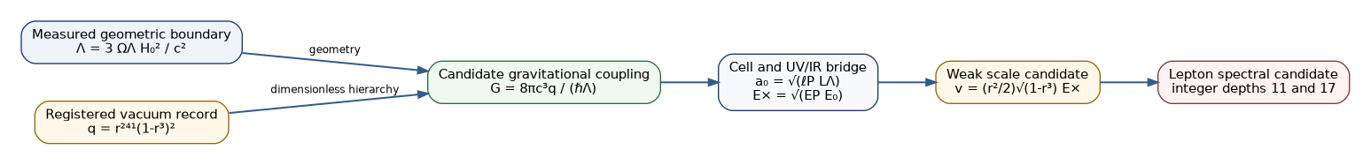
Figure 1. Closure chain from the geometric cosmological boundary to the gravitational, weak, and lepton scales. Green is numerically closed; amber and red remain representation bridges.
Numerical result. Using the same H₀=67.66 km s⁻¹ Mpc⁻¹ and ΩΛ=0.6889 boundary as the uploaded scripts gives G=6.6643853×10⁻¹¹ m³ kg⁻¹ s⁻², 0.149% below the 2022 CODATA value. Using the Planck TT,TE,EE+lowE+lensing best-estimate pair gives 6.7651243×10⁻¹¹, 1.36% above CODATA. Both are inside the indicative percent-level uncertainty propagated from the cosmological boundary; the bridge is therefore viable but not precision-confirmed.
Boundary | Λ (m⁻²) | G candidate | vs CODATA | Indicative σG
Uploaded chain | 1.105602e-52 | 6.66438529e-11 | -0.149% | 9.89e-13
Planck best | 1.089139e-52 | 6.76512435e-11 | +1.361% | 1.30e-12
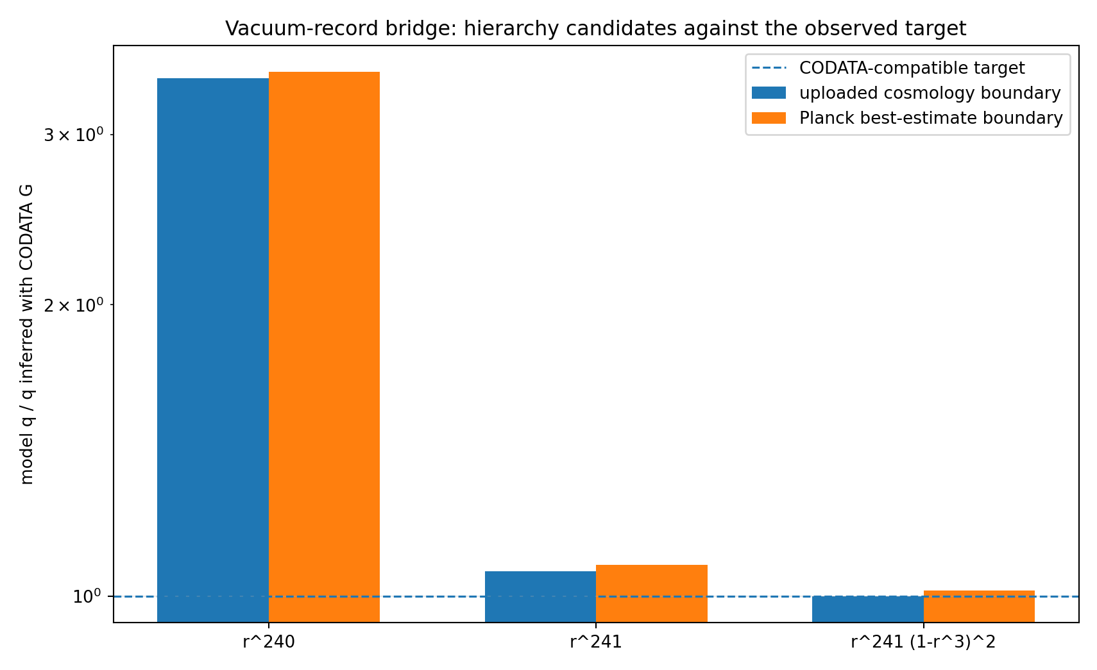
Figure 2. The 240-mode term overshoots, the 241-readout term is close, and the two-leg retained-record bridge is the nearest discrete candidate on both cosmological boundaries.
What has actually been solved: the dimensional degeneracy is gone once Λ is supplied geometrically, and there is now one explicit zero-adjustable-parameter formula for G. What remains conditional: why the physical vacuum observable is exactly the 241-mode projector multiplied by two retained traversal amplitudes.

The source sector: exact equations rather than a metaphor
The correct completion is emergent-metric in the represented scalar sector. The bubble variables are not additional matter fields placed on the right-hand side of Einstein’s equation; they reconstruct the metric that the ordinary source tensor solves for.
ds² = -e^{2A(ρ)}c²dt² + e^{2B(ρ)}(dρ² + ρ²dΩ²)

A = -α_M, B = α_L + ν/3

For this isotropic spherical metric, the orthonormal Einstein components are:
G_tt = -e^{-2B}[B′² + 2B″ + 4B′/ρ]

G_rr = e^{-2B}[2A′B′ + B′² + 2(A′+B′)/ρ]

G_θθ = e^{-2B}[A′² + A″ + B″ + (A′+B′)/ρ]

ε = c⁴G_tt/(8πG), p_r = c⁴G_rr/(8πG), p_t = c⁴G_θθ/(8πG)

This is the macroscopic source law. Given energy density and pressure, these equations solve A and B. They therefore determine the clock deformation and total spatial packing. General relativity is the toolkit, while the bubble field is the physical decoding of the metric.
Figure 3. Exact source pipeline. GR fixes A and B; one microphysical constitutive relation is required to split B into light-barrier response and number-density response.

3.1 Exact exterior
With x=GM/(2ρc²), the exact isotropic Schwarzschild fields are:
A = ln[(1-x)/(1+x)], B = 2ln(1+x)

G_tt = G_rr = G_θθ = 0
symbolically verified by the computation

Eliminating x gives the exact relation that replaces the earlier coordinate-dependent T·P=1 claim:
B(α_M) = α_M - 2ln cosh(α_M/2)

To first weak-field order B≈α_M, but the logarithmic correction is required for exact Schwarzschild geometry in isotropic coordinates.

3.2 Exact interior star
The computation reconstructs a constant-density relativistic star with compactness C=2GM/(Rc²)=0.30. The standard interior solution supplies the exact source and metric; the registered amplitude response α_L=(r/u)α_M then uniquely recovers the bubble number-density mode:
α_L=(r/u)α_M, ν=3(B-α_L), n/n₀=e^ν

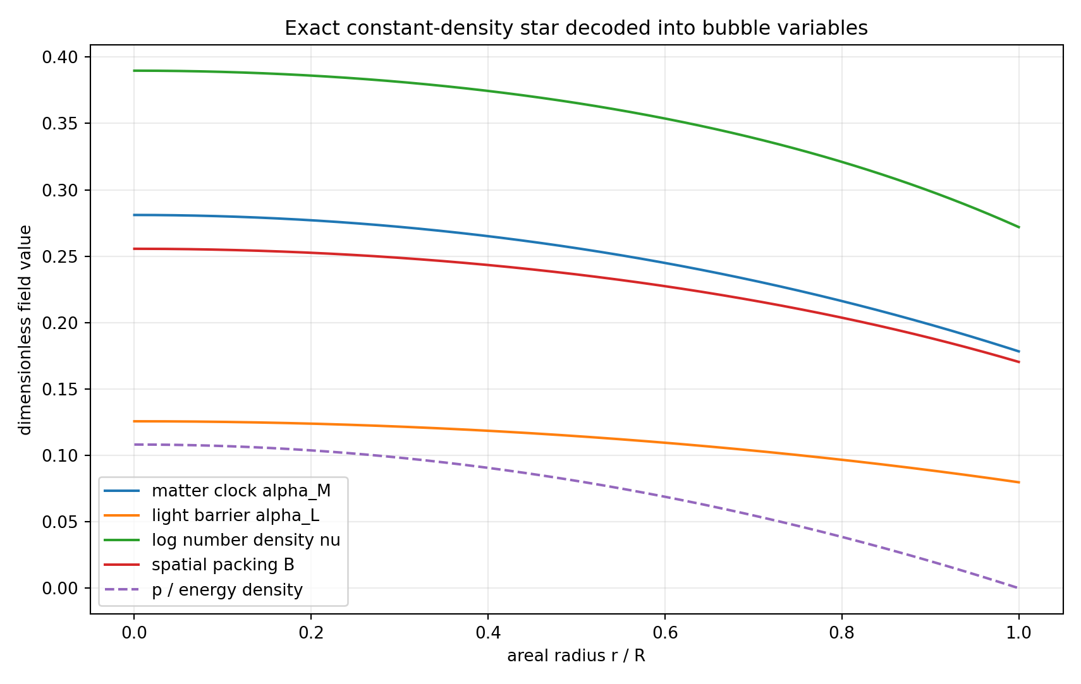
Figure 4. Exact constant-density star decoded into clock, light-barrier, number-density, and total packing variables. The central number-density enhancement is 1.4766 on the registered constitutive branch.
The numerical Einstein-equation residuals over the well-conditioned interior are below 3.2×10⁻⁴ in the dimensionless test, with median errors near 10⁻⁷ or smaller. This is a genuine source-sector solution in the spherical scalar class—not merely a plot of a supplied Newtonian potential.

3.3 Exact identifiability boundary
The metric sees B=α_L+ν/3. Therefore no gravitational measurement can separate α_L from ν by itself. This is a rank-one identifiability theorem: infinitely many pairs (α_L,ν) generate the same geometry. The response ratio r/u is the current constitutive closure, and it is the next microscopic theorem to prove or falsify.

The cell, the UV/IR bridge, and the weak scale
On the reproducibility cosmological branch, the candidate G closes the Planck length without importing G as an input. The geometric-mean identities then generate a scale ladder:
ℓ_P = √(ℏG/c³), L_Λ = √(8π/Λ), a₀ = √(ℓ_P L_Λ)

E₀ = ℏc/a₀, E_P = ℏc/ℓ_P, E_× = √(E_P E₀)

Quantity | Expression / role | Value
Whole vacuum cell | √(ℓP LΛ) | 87.7513 µm
Matter-fraction cell | W_M^{1/4} a₀ | 48.7804 µm
Vacuum cell energy | ℏc/a₀ | 2.2487 meV
UV/IR bridge | √(EP E₀) | 5.2416 TeV
The simplest registered weak-scale projection treats r²/2 as the localized routed matter fraction and √(1-r³) as the retained amplitude of one complete record cycle:
v_UF = (r²/2)√(1-r³) E_× = 246.545 GeV

This differs from the standard electroweak VEV reference by +0.132%. It closes a scale, not the gauge theory: W and Z masses still require the SU(2) and U(1) coupling normalizations and the weak mixing angle.
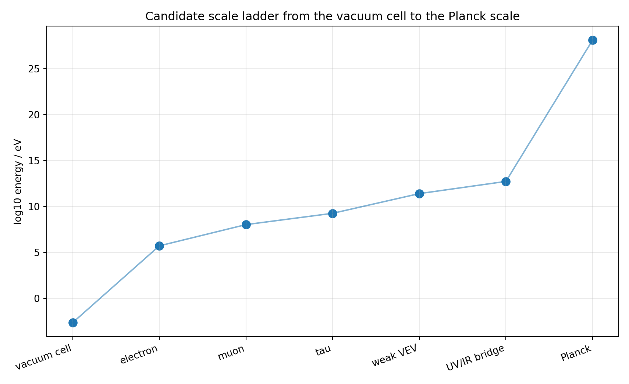
Figure 5. Candidate hierarchy from the vacuum cell through the localized masses and weak scale to the Planck scale.

Charged leptons: first absolute spectrum candidate
The previous corpus contained dimensionless generation-depth ratios but lacked an absolute scale. The weak-scale bridge now supplies that dimensional anchor. The following spectrum is registered as a candidate—not yet promoted to a theorem:
m_e = v r¹¹(1-r/2)

m_μ = m_e φ¹¹(1+r³)

m_τ = m_e φ¹⁷(1-r³)

Lepton | Candidate (MeV) | Reference (MeV) | Relative error
Electron | 0.511460267 | 0.510998951 | +0.090%
Muon | 104.786631 | 105.658376 | -0.825%
Tau | 1772.52971 | 1776.86 | -0.244%
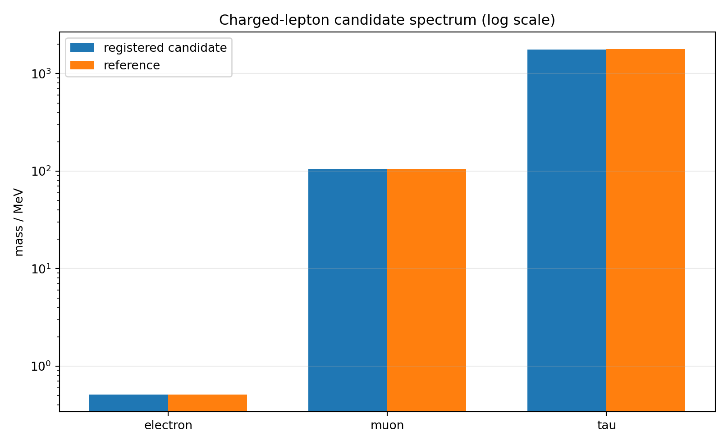
Figure 6. Registered charged-lepton candidate compared with reference masses on a logarithmic scale.
What this achieves: the lepton problem is no longer dimensionally underdetermined; one absolute scale now produces all three candidates. What is still owed: a localized phase/winding mass operator whose eigenvalue multiplicities force the depths 11 and 17 and the two-sided electron factor. Until that operator exists, the table is a sharply registered spectrum hypothesis, not a derivation.

Range hierarchy and the confinement correction
The qualitative range hierarchy becomes exact once the three channels are assigned quadratic response operators. The Green function, rather than a verbal label, determines the range.
Channel | Quadratic operator | Green-function behaviour | Range
Light | -∇² | 1/r | infinite
Boundary | -∇² + m_B² | e^{-m_B r}/r | finite
Matter | m_M², no spatial kinetic term | local algebraic response | zero/contact
The boundary range is the weak-scale problem in another form: a finite range requires a boundary mass m_B, while the weak VEV supplies only the symmetry-breaking scale. The gauge normalization remains open.

6.1 Confinement: exact inversion, not yet prediction
For a causal one-cell flux tube with a=ℏc/E, energy density ρ=E/a³, and cross-section a², the tension is identically:
σ = ρa² = E/a = E²/(ℏc)

The measured QCD-like tension 0.18 GeV² therefore corresponds to E=0.424 GeV and a=0.465 fm. This repairs the earlier factor-of-five statement: the field can exactly translate tension into a local cell scale, but it has not yet predicted that scale from the vacuum cell. The next dynamical task is to derive why the matter-sector floor selects this local energy.

6.2 Negative results retained
- Vacuum-cell string tension is excluded by roughly 10²³; the QCD string is not an 88 µm vacuum bubble.
- Vacuum crowding energy is excluded as the missing dark-matter density by roughly 10¹¹ in galaxies.
- These no-go results are structural and are not repaired by changing an order-one channel coefficient.

7. Final closure ledger
EXACT | Solved exactly
- three-part partition and traversal floor algebra
- isotropic scalar-sector Einstein/source equations
- exact Schwarzschild representation and exact B(alpha_M) relation
- constant-density star reconstruction into bubble variables
- range classification for the stated quadratic operators
- G/Lambda are the same dimensionless hierarchy question

CONDITIONAL | Closed under explicit representation bridges
- G from q=r^241(1-r^3)^2 and a measured geometric Lambda
- light/density split alpha_L=(r/u)alpha_M
- weak VEV scale candidate
- charged-lepton candidate spectrum

OPEN | Still open and decisive
- derive the two-leg vacuum-record representation rather than postulate it
- derive the alpha_L/alpha_M response ratio from a microscopic least-cost action
- derive electroweak gauge couplings and mixing
- derive the lepton mass operator and force generation depths
- extend the scalar/spherical reconstruction to general tensor/shear geometry

7.1 Falsification order
- Vacuum hierarchy: obtain a tighter geometric Λ boundary and compare the predicted G before changing any discrete factor.
- Source microphysics: derive α_L/α_M from a least-cost cell action; the current r/u law must be frozen before confronting independent lensing and clock data.
- Weak sector: derive g and g′, then predict W, Z, and the weak mixing angle without using their measured values.
- Leptons: construct the mass operator and show that its spectrum forces the declared depths. Failure to force them demotes the mass formulas to numerology.
- Short-distance gravity: derive the actual observable transfer function of a 48.8–87.8 µm cell structure; a length alone is not an experimental signature.

7.2 The strongest concise statement
matter source → (A,B) geometry → (α_M, α_L, ν) cell map

Λ + q_UF → G → a₀ → E_× → v → candidate masses

The first chain is exact in the represented spherical scalar class. The second is now a single explicit conditional bridge rather than an unnamed missing number. That is the genuine advance of this closure pass.

Appendix A. Reproducibility and provenance
The accompanying Python script regenerates every number and all figures in this paper. The JSON certificate records formulas, numerical values, statuses, and remaining obligations.
File | Role
bubble_field_closure_attack.py | full calculation
bubble_field_closure_attack_results.json | machine-readable certificate
bubble_field_G_bridge.png | hierarchy comparison
bubble_field_source_profiles.png | interior source reconstruction
bubble_field_scale_ladder.png | scale hierarchy
bubble_field_lepton_candidate.png | lepton candidate comparison

Appendix B. Source documents and external references
- Shields, J. The Bubble Field: Gravity as overcrowding in a sea of least-action cells. Working paper, 29 July 2026.
- Shields, J. Least-Cost Holonomy and Co-Distinction Fields: The Shields Field of Distinct Actions. Working paper, 28 July 2026.
- Shields, J. Unified Mechanics, 2026 bridge-closure editions. Conditional 240-mode vacuum residual, 241st readout, channel routing, and traversal floor.
- Planck Collaboration. Planck 2018 results VI: Cosmological parameters. Astronomy & Astrophysics 641, A6 (2020).
- NIST/CODATA. 2022 recommended value of the Newtonian constant of gravitation: 6.67430(15)×10⁻¹¹ m³ kg⁻¹ s⁻².
- Standard exact solutions used as toolkits: isotropic Schwarzschild exterior and constant-density Schwarzschild interior.
END OF CLOSURE ATTACK

